**englische Zusammenfassung**

O

rganisation is an integral component of the management. Stratecig planing, information technology, culture and organisation have to be coordinated with each other. Organization is also an element in the chain of effects within the administration and, in addition to the areas of strategic planning, human resources management and controlling.

The goal setting are based on political requirements. This political goal setting coordinates or interact with all the other elements of management. Elements of management are personnel, organization, information technilogy and budget.

This cooperation effects the quality of administrative action. If there is no interaction, that plan can not be problem solving. It is very important that you involve this interaction in every single planning step. Otherwise, your plan or solution will sooner or later break apart.

In a nutshell this means that a solution for problem A must not affect a or leave to a deterioration for problem B. A solution has to be a step forward for every single element of management.

It is also very important that the motivation and qualification of the employees does not decreases if planning to change somthing. A solution can be good for the company but if the employees are not willing to do so much, this solution will not work very well.

In particular the information technology sector is very sensitive because employees have to know how to do tasks on the computer if you want them to do so. As a result, it is logical that a solution can not become true if the knowledge of the employees is not as good as you thought.

On the one hand, the strategic level, employees have to learn how to do their jobs. Maybe they need to go to an advanced training course to learn more about a specific topic.

On the other hand, the operational level, tasks have to be easy to accomplish on the base of the knowledge from the employees.

The real goal of the management is the performance of public administration tasks of various types for different clients. Information technology is essential to enable the efficient and effective creation of services of appropriate quality at present and in the future. You need to see management not as the end in itself. Insteat management leads to services and thus also to customer satisfaction. As a result, organisators have to work closely together with information techology employees.

F

ollowing picture shows the different phases of an organizational project. As you can see there are five important phases: the preparation, the preliminary investigation, the main investigation, the implementation and the evaluation (in this order).

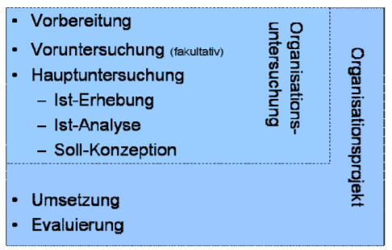

M

y focus is the preliminary investigation (other people will tell you sth about the other four phases…). The preliminary investigation is optional but very useful if employees do not understand the real problem or the definition auf goals because these to points are the main points of the preliminary investigation. It gives the employees a perfect overview of the areas of investigation and it provides the clear definition of the main problems and main goals. Moreover, in the preliminary investigation phases everybody should think about following question: Can the investigation be carried out within the planned framework and capacities?

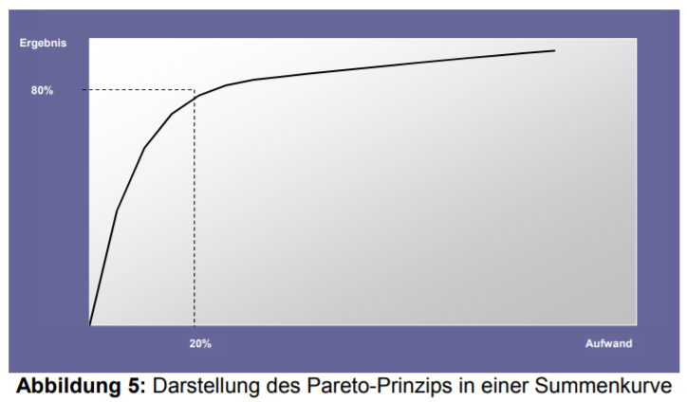There are two easy-to-understand graphics or rules which describe firstly the effort of a task and secondly the error costs. The Pareto principle shows that 80 percent of a task can be done with 20 percent of effort and the other 20 percent of this task can be accomplished with 80 percent of effort (some of you might know the situation very one semicolon is missing in some programming code… [80 percent effort] 😊).

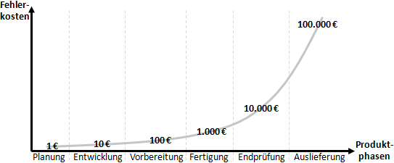The second graphic shows that the price of the errors is increasing the more time goes by. In a nutshell: If you discover an possible error early enough (for example in the preliminary investigation phase) the company has to pay much less money to get rid of this error than it would had to have if you would not have discovered this error.

Some advantages of the preliminary investigation phase are:

* Securing the problem and goal definition,
* manageable steps,
* low personnel capacity,
* possibility of error prevention,
* fast problem solution (if necessary) and
* planning reliability.

The results of the preliminary investigation should be:

Statements about the feasibility, concrete project assignment, overview of the main focal points of the investigation, detailed definition of the approach and methods, detailed project planning, forecast of expected costs (internal resources) and expenses expenses, forecast of expected savings potential.